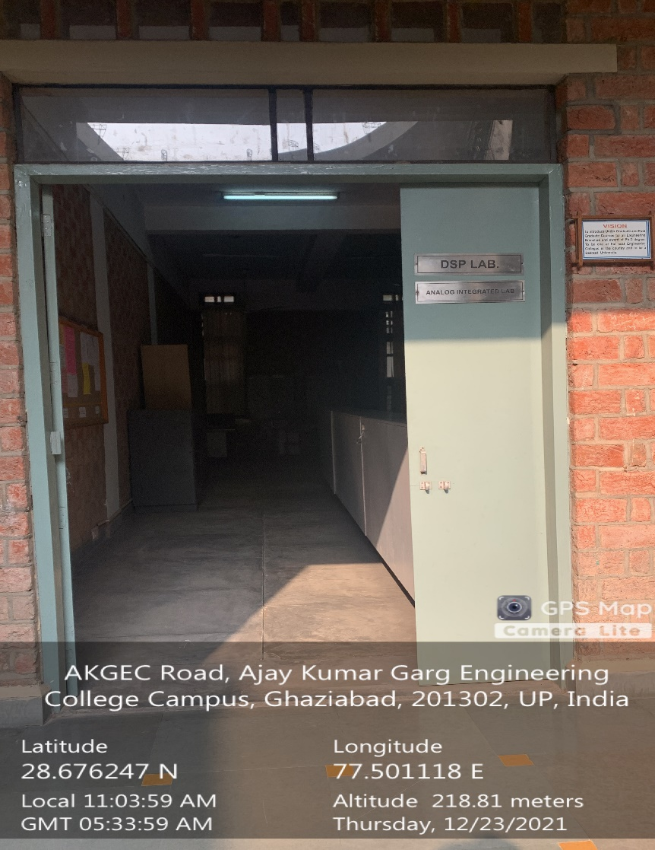

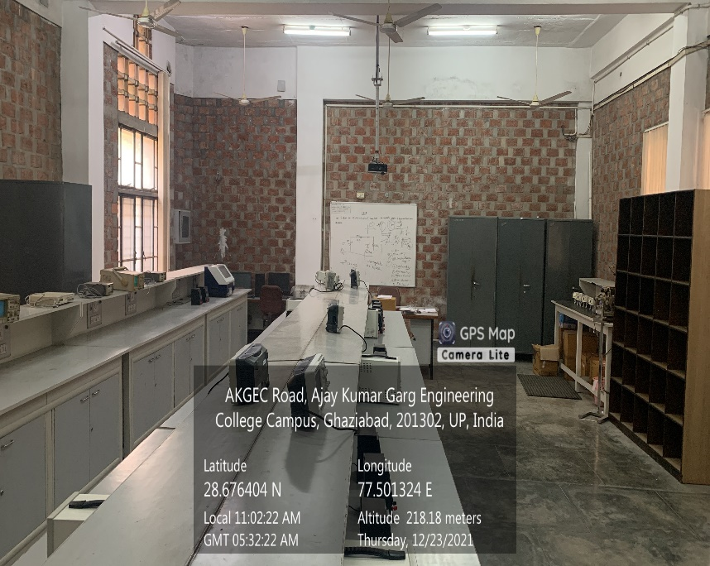

**Back Block, First Floor, E&I BASIC ELECTRONICS & PCB DESIGN CUM MINI PROJECT LAB**

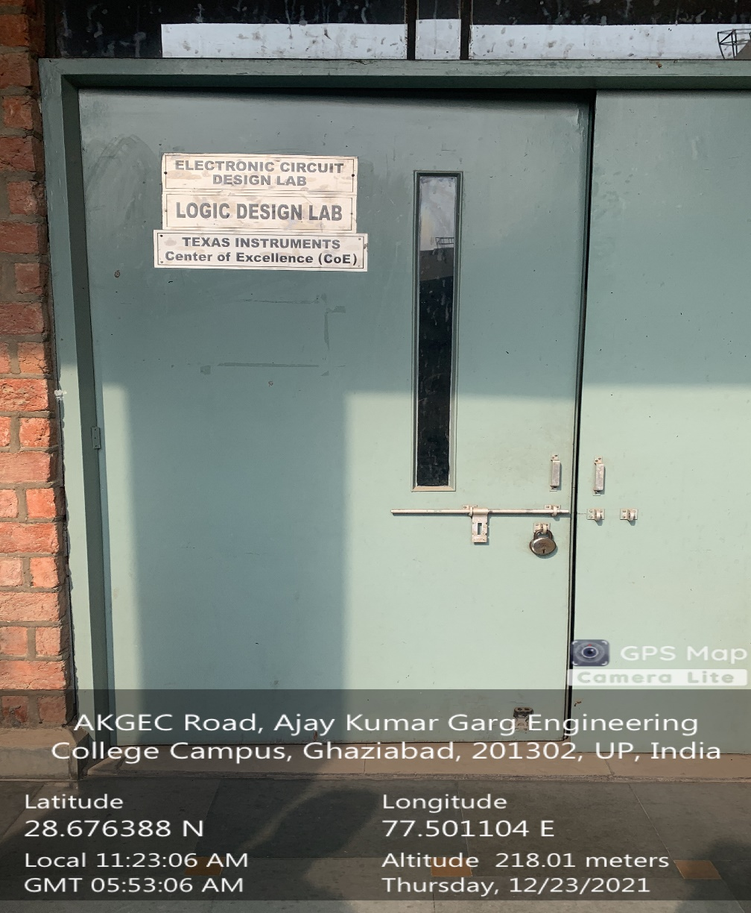

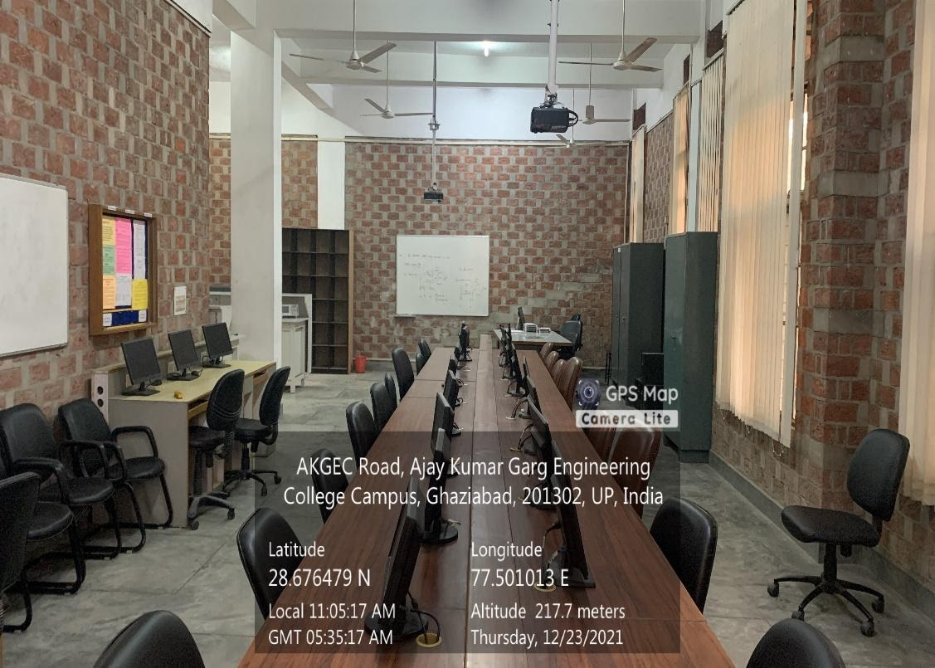

**Back Block, Second Floor, E&I DIGITAL SYSTEM DESIGN LAB**

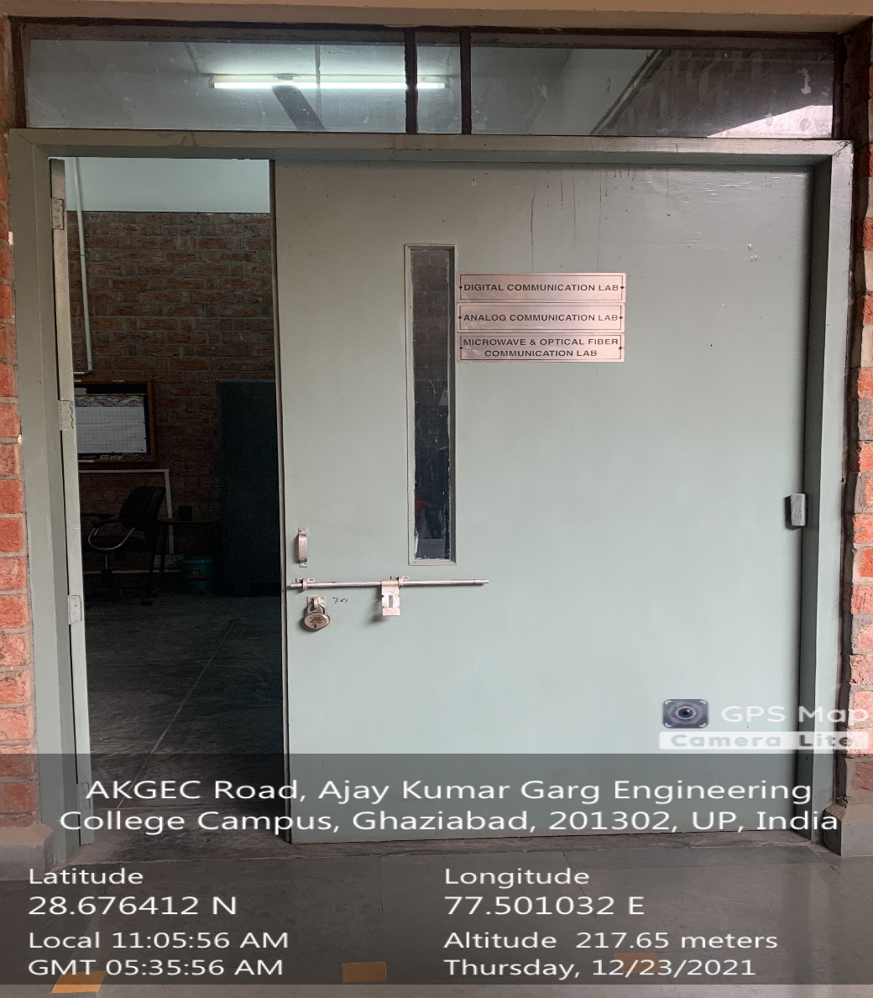

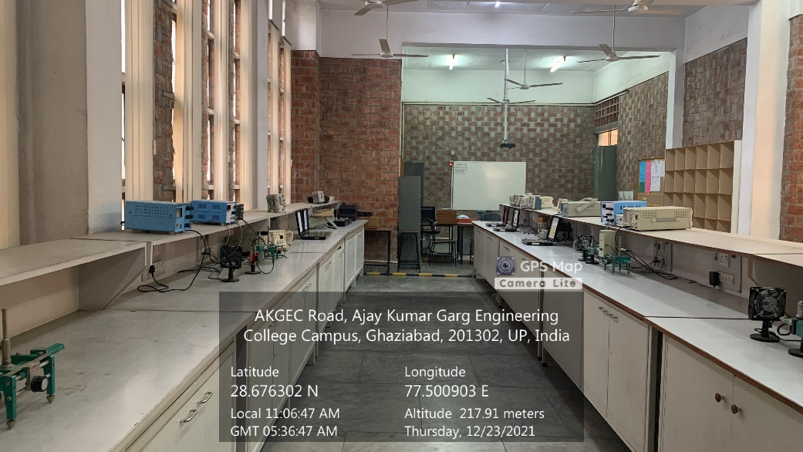

**Back Block, First Floor, E&I ELECTRONICS DEVICES AND ANALOG CIRCUITS LAB**

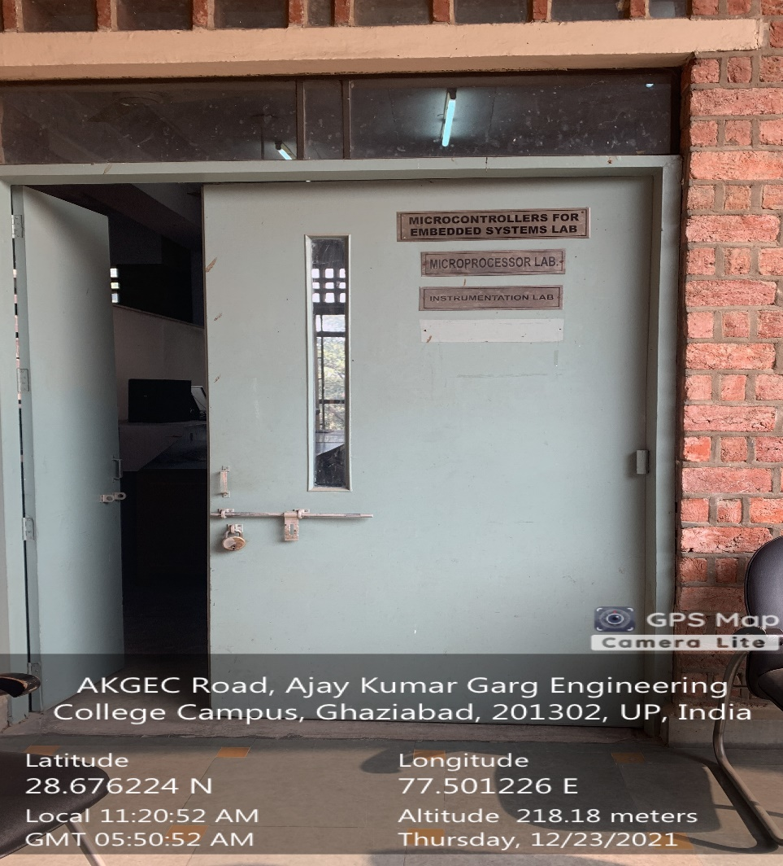

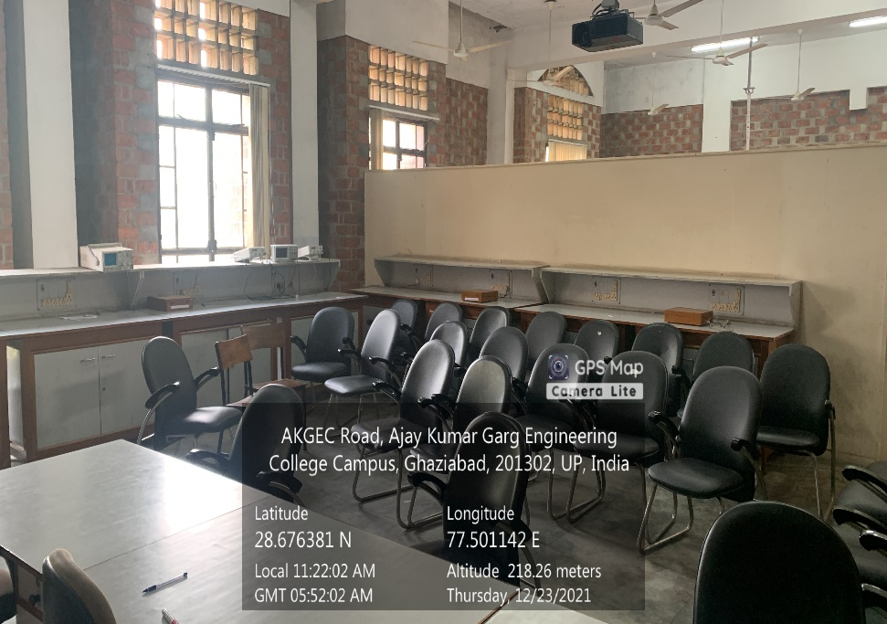

**Back Block, Second Floor, E&I ELECTRONICS MEASURMENT, INSTRUMENTATION AND TRANSDUCERS LAB**

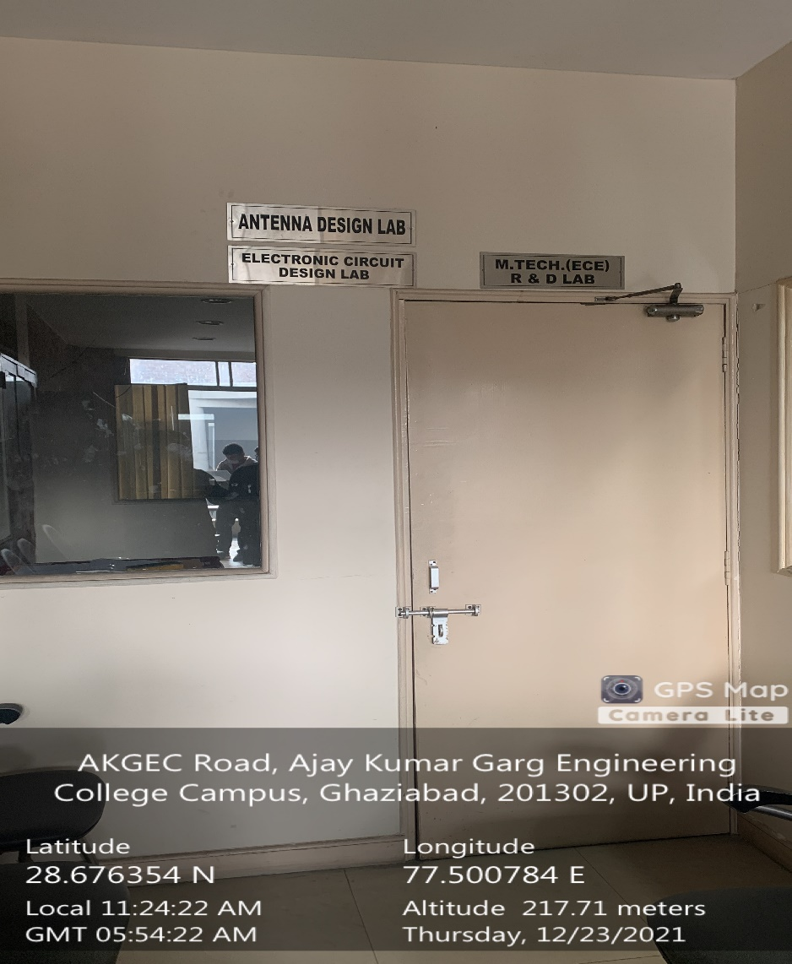

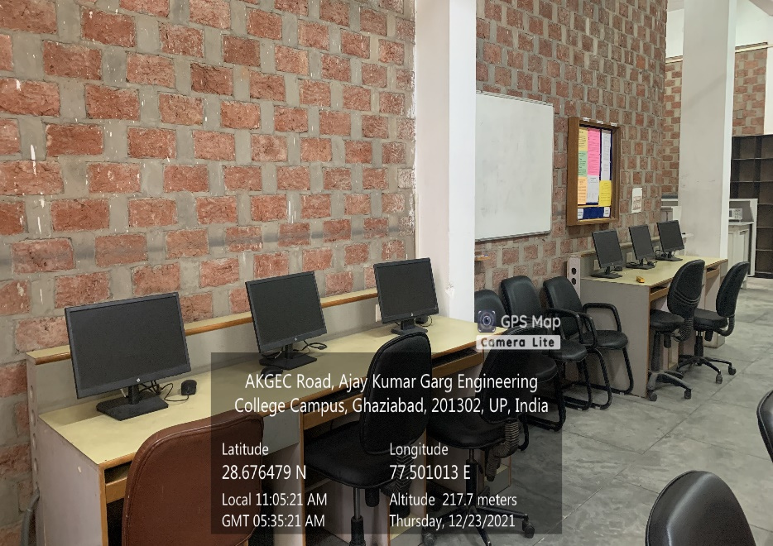

**Back Block, First Floor, E&I INTEGRATED CIRCUITS LAB**

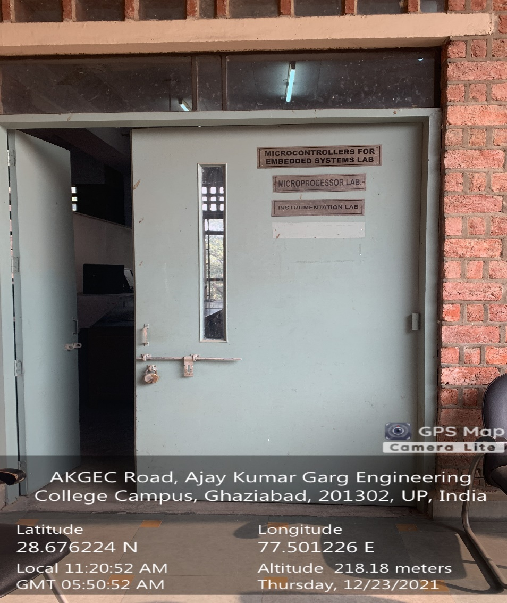

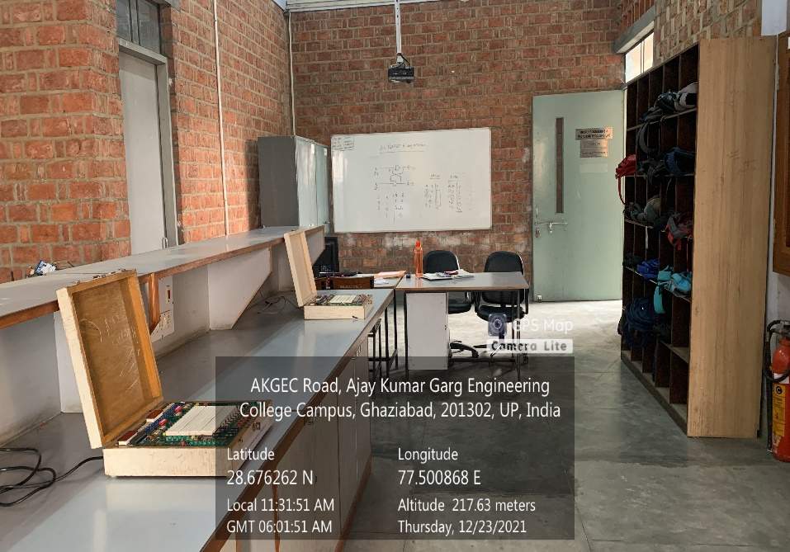

**Back Block, Second Floor, E&I MICROPROCESSOR & MICROCONTROLLER LAB**

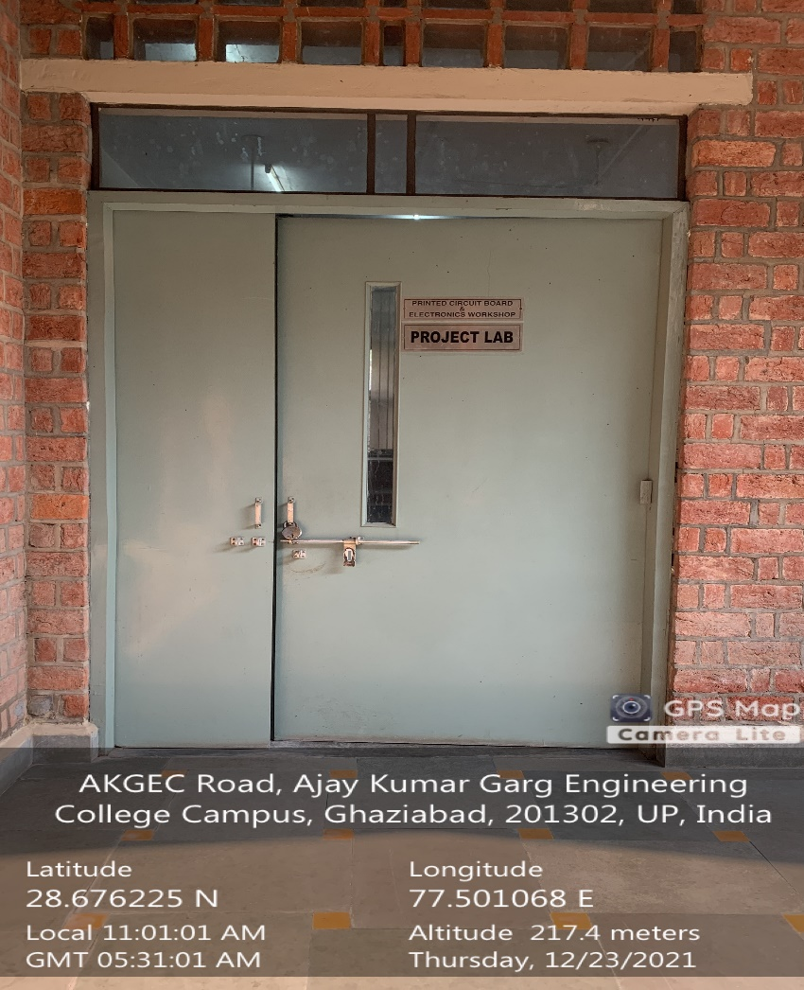

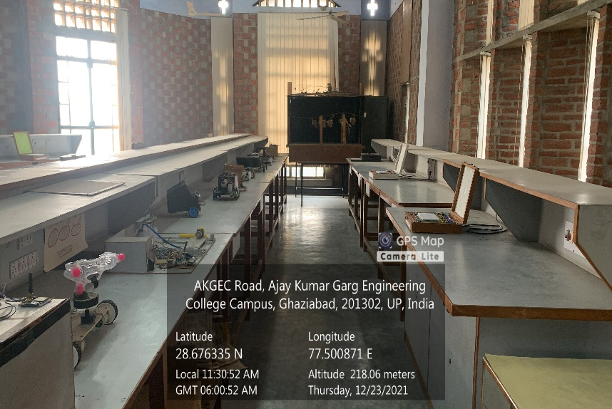

**Back Block, Second Floor, E&I PROJECT LAB**

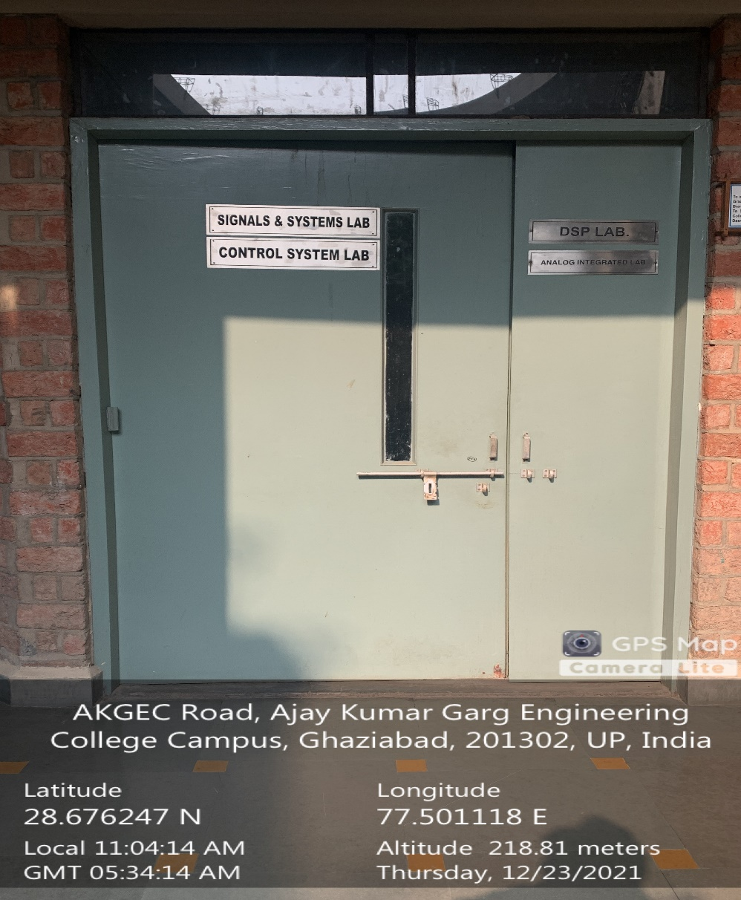

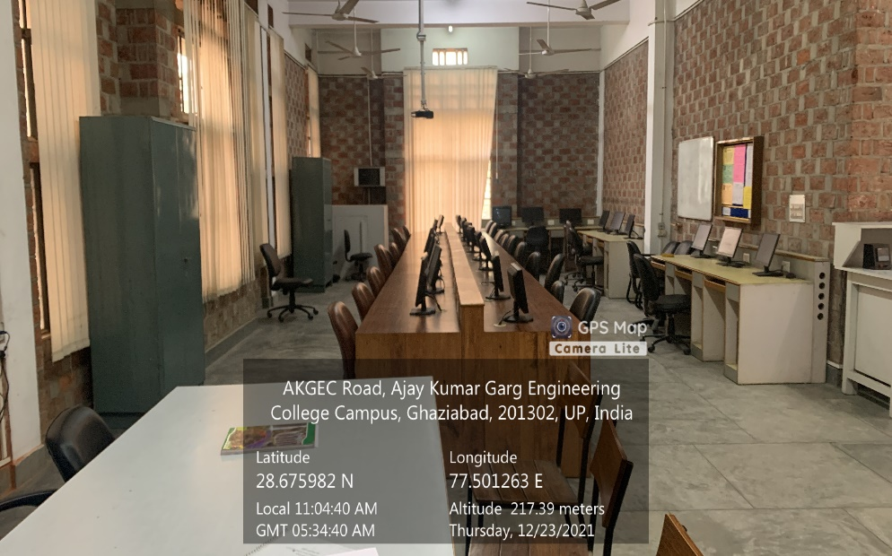

**Back Block, Second Floor, PROGRAMMING & CONTROL SYSTEM LAB**

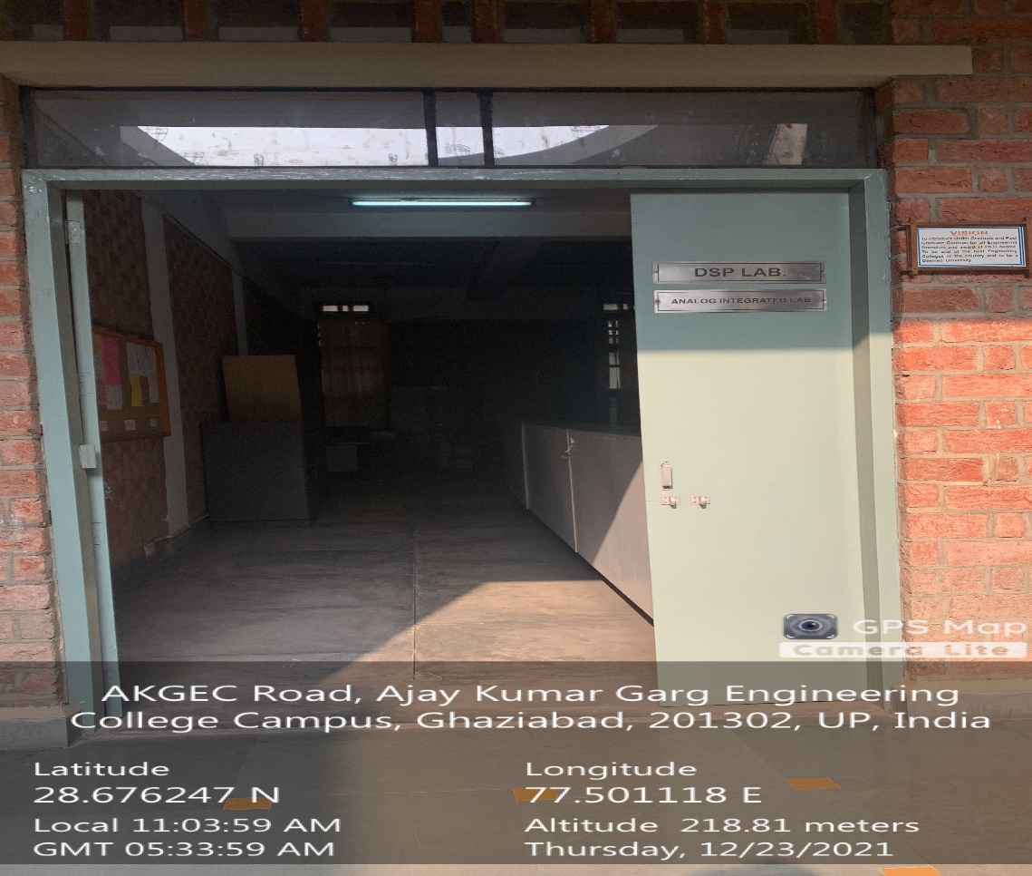

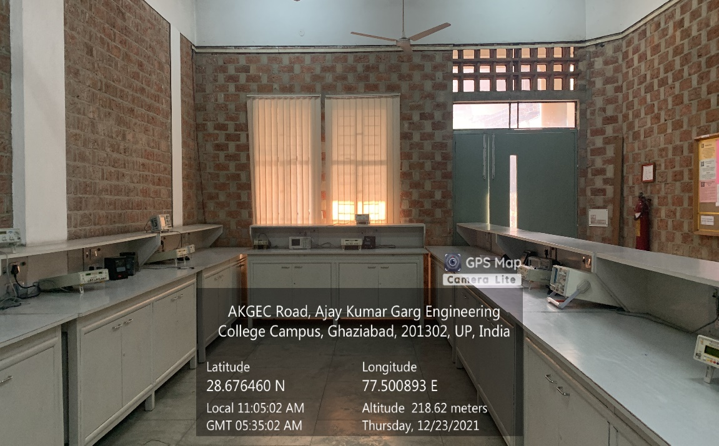

**Back Block, First Floor, SIGNAL SYSTEMS AND DSP LAB**

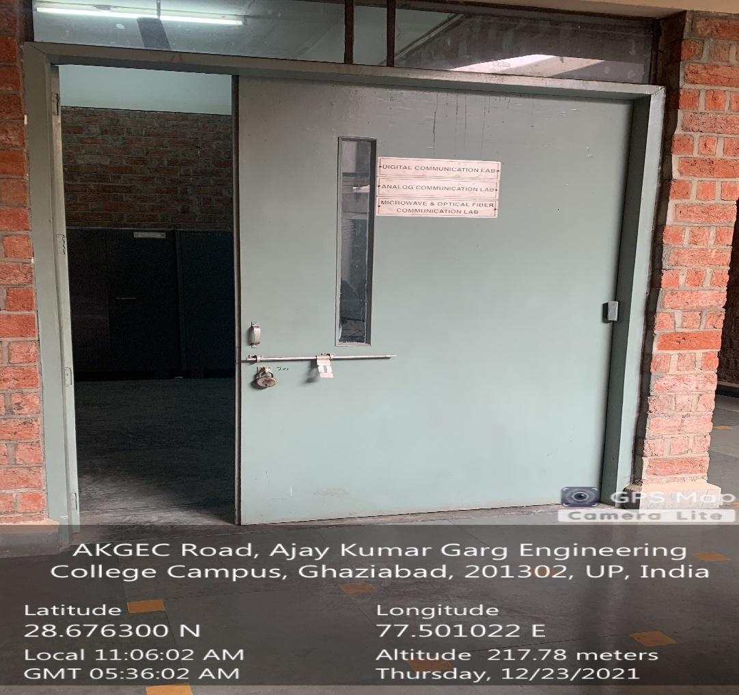

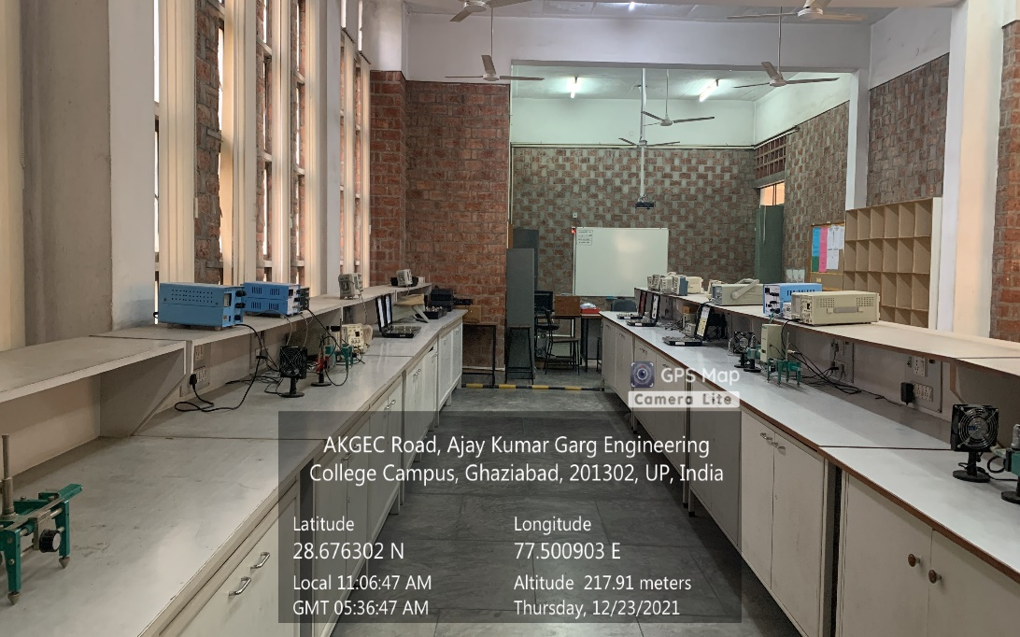

**Back Block, First Floor, TELEMETRY & COMMUNICATION LAB**